Confort 15: user guide
Silvia Campagnola*, Claudia Romano, Larry G. Mastin, Alessandro Vona

*Contact information:
E-mail: silvia.campagnola@hotmail.it
URL: http://evplab.it/silvia-campagnola.html

Confort 15 is an implemented version of Conflow numerical model (Mastin and Ghiorso, 2000) using updated rheological constitutive equations concerning both the liquid viscosity and crystal-bearing rheology. Moreover, decompression rate calculations are implemented, using Vesicle Number Densities (VNDs) obtained from the textural analyses and Toramaru (Toramaru, 1995, 2006) decompression rate meter.
Confort 15 can be applied to all natural magma compositions, also including the peralkaline melts excluded in the original version. Furthermore, the crystal-bearing rheology is improved by computing the effect of strain rate and crystal shape on the rheology of natural magmatic suspensions and expanding the crystal content range in which rheology can be modeled compared to the original Conflow model (Conflow is applicable to magmatic mixtures with up to 30 vol% crystal content).
Confort 15 is written in Fortran 90 and can be operated on any platform that has such a compiler.

Section 1: Confort 15 implementations
Conflow is described in detail by Mastin and Ghiorso (2000) and advantages of the modeling procedure toghether with the shortbacks and limitations of it are described in detail there and in Campagnola et al., ***.

Rheology
In our modified version of Conflow (hereafter Confort 15), the liquid viscosity is calculated using the GRD model (Giordano et al., 2008) which predicts the non-Arrhenian temperature dependence of viscosity for naturally-occurring silicate melts at atmospheric pressure (10⁵ Pa). The temperature dependence of viscosity (η) is modeled by the Vogel–Fulcher–Tammann (VFT) equation
$$logη=A+\frac{B}{T\left(K\right)-C}$$
where $T\left(K\right)$is the temperature in Kelvin, $A$ is a constant independent of composition and $B$ and $C$ are adjustable parameters.
The compositional dependence of viscosity is taken into account in the $B$ and $C$ parameters as linear combinations of oxide components (mol%) and several multiplicative oxide cross-terms:
$$B=\sum_{i=1}^{7}{\left[b_{i}M_{i}\right]+\sum_{j=1}^{3}{\left[b_{1j}({M1}_{1j}∙{M2}_{1j})\right]}}$$
$$C=\sum_{i=1}^{6}{\left[c_{i}N_{i}\right]+}\left[c_{11}({N1}_{11}∙{N2}_{11})\right]$$
where the $M$ and $N$ are combinations of mol% oxides for $B$ and $C$ respectively. The 17 unknown coefficients ($b_{i}$, $b_{1j}$, $c_{i}$, $c_{11}$) are used to compute the values of $B$ and $C$ for any individual melt composition (for details see Giordano et al., 2008). Although this model is able to accurately predict the viscosity of metaluminous and calcalkaline magmas, substantial deviations take place for peralkaline compositions.
For this reason, we adopt the Di Genova et al. (2013) parameterization for peralkaline melts, based on a modified Vogel–Fulcher–Tammann equation, accounting for the effect of water and composition. In the Fortran subroutine, we introduce a simple agpaitic test: if the SiO₂ is greater than 59% and at the same time the ratio between alkali (Na₂O+K₂O) and Al₂O₃ exceeds unity (1), the test is satisfied and Confort 15 utilizes the Di Genova et al. (2013) equation:
$$\log{\text{η= }A}+\frac{b_{5}+b_{6} × log⁡(1+H_{2}O)}{T\left(K\right)-\left[\frac{c_{5}+c_{6}× log⁡(1+H_{2}O) }{AEX}\right]}$$
where A is a constant independent of composition and has a value of −4.55 Pa s (as in Giordano et al., 2008), $b_{5}, b_{6 }, c_{5},c_{6}$ are fitting parameters, T is the absolute temperature, $H_{2}O$ is the water concentration in mol% and $AEX$ is the alkali excess in mol% (for details see Di Genova et al. 2013).
In Confort 15, also the parameterization of particle suspension viscosity is implemented. We insert Vona et al. (2011) equation, which takes into account not only the crystal content, but also the crystal shape and the strain-rate undergone by the suspension, as all are demonstrated to play primary roles in influencing the transport properties of magmas. In particular, the relative viscosity ($η_{r}$) is expressed as:
$$η_{r}={\left(1-\frac{ϕ}{ϕ_{m}}\right)}^{-2\left[1-α\log\left(\dot{γ}\right)\right]}$$
where $\dot{γ}$ is the applied strain rate, $α$ is a constant equal to 0.06 and $ϕ_{m }$represents the maximum packing fraction.
The values of $ϕ_{m }$are calculated on the basis of the average aspect ratio using the equation by Mueller et al. (2010):
$$ϕ_{m }= \frac{2}{0.321\overline{R}+3.02}$$
which has been calibrated to empirically fit their data on analog suspensions containing monodisperse particles of fixed aspect ratio. We calculate the average aspect ratio $\overline{R}$ according to the following equation (Vona et al., 2011):
$$\overline{R}= \frac{\sum{ϕ_{i}\overline{R_{i}}}}{ϕ}$$
where $ϕ_{i}$ and $R_{i}$ are the crystal fraction and the mean aspect ratio of phase $i$.
In our new Confort 15 program, we are able to insert up to three different crystal phases with the relative crystal density and aspect ratio of each phase and calculate the multiphase rheology according to Vona et al. (2011) equation.
Due to its functional form, Vona et al. (2011) equation can be used only for $ϕ<ϕ_{m}$, as viscosity increases exponentially toward infinity as the crystal-volume fraction approaches $ϕ_{m}$. In the case where $ϕ$ exceeds $ϕ_{m}$, Confort 15 considers the Costa et al. (2009) model, that takes into account the shear rate ($\dot{γ}$) dependence of the suspension rheology. The relation between relative viscosity and the solid fraction is given by:
$$η\left(ϕ\right)=\frac{1+φ^{δ}}{{\left[1-F\left(φ,ε,γ\right)\right]}^{Bϕ^{*}}}$$
where
$$F=\left(1-ξ\right)erf\left[\frac{\sqrt{π}}{2\left(1-ξ\right)}φ(1+φ^{γ})\right]$$
with $φ$ = $ϕ{/ϕ}^{*}$ where $ϕ^{*}$, ξ, γ and δ are empirical parameters that depend on the deformation rate and B is the Einstein coefficient. Although this model can successfully predict the multiphase rheology of suspensions containing $ϕ$ = 0.1-0.8 isotropic particles for a wide range of strain rates, it can produce appreciable errors when the aspect ratio of the solids increases.

Decompression rate calculations
A Confort 15 further improvement with respect to previous modeling consists of the characterization of decompression rates as inputs, calculated via the Vesicle Number Densities per volume (VNDs, i.e. number of vesicles per unit volume of melt) obtained from the textural analyses of the erupted products. VNDs represent the integrated result of bubble nucleation through time and provide information on bubble nucleation and can provide essential information on the style of ascent and magma decompression rates (Toramaru, 1989, 1995, 2006; Cashman and Mangan, 1994; Klug et al., 2002). VNDs depend strongly on magma properties such as surface tension (melt-vapor and crystal-vapor) and volatile diffusivity, as well as on the timescale available for vesicles to nucleate (i.e. decompression rate) (e.g. Hurwitz and Navon, 1994; Toramaru, 1995). If magma properties are known, VNDs can be translated directly into decompression rates. As in Mourtada-Bonnefoi and Laporte (2004), Cluzel et al. (2008) and Shea et al. (2011), this conversion is achieved using the equations presented in Toramaru (2006):
$${Nv}_{calc}=34X_{0}α_{1}^{-2}α_{2}^{-1/4}α_{3}^{-3/2}$$
where $X_{0}$ is the initial water concentration at the saturation pressure, and $α_{1}, α_{2}, α_{3}$ represent dimensionless parameters (Toramaru, 1995) defined as:
$$α_{1}=\frac{16πσ^{3}}{3kTP_{0}^{2}}$$
$$α_{2}=\frac{Ω_{M}P_{0}}{kT}$$
$${ α}_{3}=\frac{kTX_{0}DP_{0}^{2}}{4σ^{2}\left|\frac{dP}{dt}\right|}$$
where $dP/dt$ is the decompression rate, $k$ is the Boltzmann constant, $Ω_{M}$ is the volume of water molecules in the melt taken as 2.6×10⁻²⁹ m³, $P_{0}$ is the initial pressure, $T$ the temperature in Kelvin, $σ$ the surface tension and $D$ the water diffusivity depending primarily on temperature and dissolved water content in melt (e.g. Zhang and Behrens, 2000). In order to capture the decompression rates corresponding to the final stages of rapid ascent prior to fragmentation (Toramaru, 1995; Shea et al., 2011), we only used number densities calculated for the smallest size range. In other words, we did not consider in the calculation larger vesicles that may have experienced expansion and possibly coalescence.
Thus, in all equations for the calculation of the decompression rate, the initial pressure and water contents need to be reset at values corresponding to late-stage nucleation. Taking into account the porosity of the selected vesicle size range, we can recalculate the water content at porosity $ϕ$, $X_{0}$, by rearranging the equilibrium model presented in Gardner et al. (1999) as demonstrated by Shea et al. (2011):
$$X_{0}=X_{i}-\frac{ϕ}{\frac{ρ}{Z}{\overline{V}}_{w}(1-ϕ)}$$
where $X_{i}$ is the original initial water content, $Z$ is the molecular weight of water, ${\overline{V}}_{w}$ is the molar volume of water in the vapor phase, and $ρ$ the magma density.
After all necessary parameters are obtained, curves of $dP/dt$ vs.${Nv}_{calc}$ are used to determine the decompression rate that best matches different surface tension $σ$. The surface tension $σ$ is the most difficult parameter to estimate, as it depends on several factors such as chemical composition of the melt, water content and temperature. Effective surface tension in different compositions, such as dacites, rhyolites and phonolites, spanning between 0.01 and 0.1 N/m have been reported in literature (Bagdassarov et al., 2000; Mangan and Sisson, 2000; Mourtada-Bonnefoi and Laporte, 2004; Massol and Koyaguchi, 2005; Shea et al., 2011).

Section 2: Running the model
Confort 15 reads from the ASCII input file “conin”, which resides in the same directory and can be edited using any text editor. The file appears as follows:
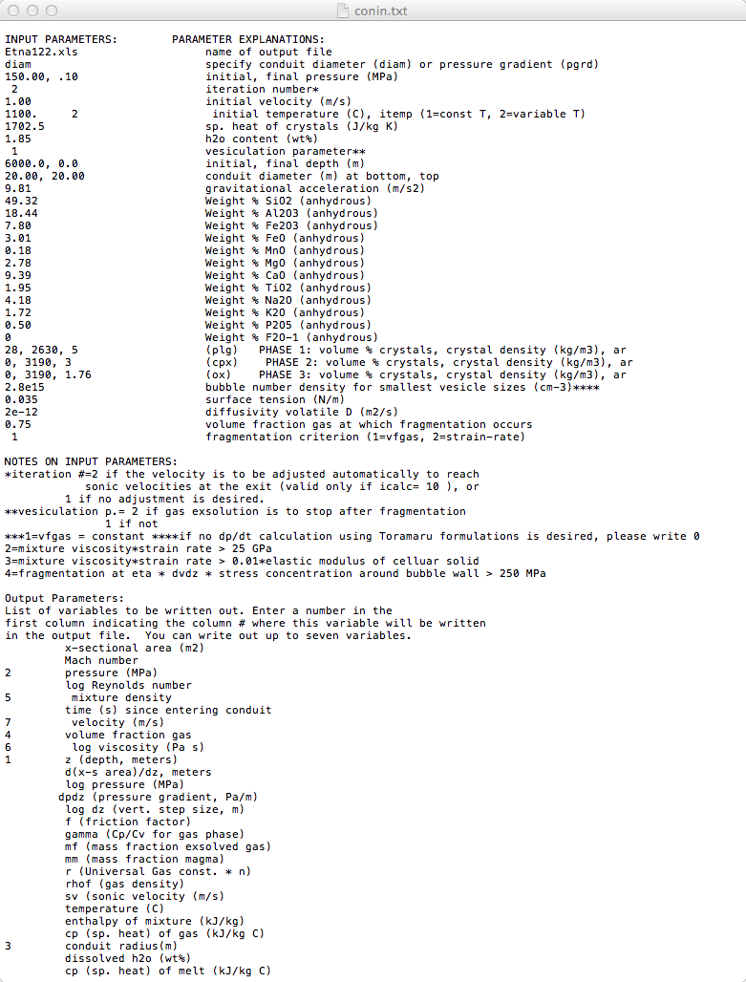
The right-hand side of each line explains (briefly) what each parameter represents.
Parameter explanations that require somewhat more information are followed by asterisks, with supplemental information on following lines.
Detailed information for parameters already present in Conflow is reported in the software manual (Mastin and Ghiorso, 2000, http://pubs.usgs.gov/of/2000/0209/pdf/of2000-0209.pdf).

Parameters inserted in the new Confort 15 version are the following:

- Rheology-parameters (see section 1.1)
- The melt composition was improved adding several component oxides (MnO, P₂O₅, F₂O₋₁) useful to calculate viscosity using the new formulations.
- The user could insert up to three different crystal phases with the relative crystal density and aspect ratio of each phase. These values are used to calculate the crystal-bearing viscosity according to new formulations.

- Decompression rate-parameters (see section 1.2)
- Bubble Number Density (BND) for smallest vesicle sizes (cm⁻³), derived from independent textural analysis. In the case in which the user don’t want to use the BND-based decompression rate may write '0' in this line.
- The bubble-melt surface tension (N/m), the most difficult parameter to estimate for decompression rate decompression rate calculations. Based on literature data, different values of surface tension could be utilized in simulations as a function of anhydrous liquid composition and water content.
- The water diffusivity D (m²/s), which depends primarily on temperature and dissolved water content in melt (e.g. Zhang and Behrens, 2000).

The last 37 lines of the input file contain the names of variables that can be written to the output file for each depth. The user must specify seven variables to be written out. For each variable to be written out, enter a number at the beginning of the appropriate line corresponding to the column in the output file where this variable will appear.

Once the program is started, it will first write out on your screen:
You calculated the dpdt using Toramaru formulations. Your resulting dpdt is: 0.5883E+00MPa/s
Do you wish to continue? (y/n):
If you enter 'y', the program will calculate the pressure gradient on the base of your Bubble Number density (and hence your decompression rate). If you enter 'n', the program will continue without taking into account your resulting decompression rate. The user may also decide not to take into account the Bubble Number Density-based decompression rate writing '0' in the “conin” input file in the “Bubble Number Density (BND) for smallest vesicle sizes (cm⁻³)” line.

Then, if the total of melt component oxides differs by more than 0.1% from 100%, you will receive the following error message:
total of component oxides does not equal 100%.
Adjust automatically? (y/n)
If you enter 'y', the program will adjust the weight percent of each oxide proportionately so that the total equals 100%. If you enter 'n', the program will stop and you must edit the input file and try again.

At this point, Confort 15 prints the input values to the output window and then the fragmentation criterion and the viscosity equations, which it chooses according to your data.

Next, the program will begin calculating flow properties from the bottom to the top of the conduit as described in Mastin and Ghiorso (2000). Once the program completes its calculations, one could open the output file and plot our selected parameters results.

Included in the zip file is a list of subroutines and what they do. Moreover, a text file named “Confort 15 routine” is included, which gives an idea of which subroutines are dependent on which other subroutines. It is a useful tool to facilitate the execution of the program, providing a possible subroutines order to compile the Fortran codes and to produce and run the executable file.

Closing comments
In the related paper “Confort 15: an implemented version of Conflow numerical model using updated rheological constitutive equations. Application to the Pantelleria Green Tuff and Etna 122 BC eruptions.” (Campagnola et al., ***) the program was applied to two natural cases in order to evaluate and quantify how much these upgrades affect the conduit dynamics during magma ascent: the Pantelleria Green Tuff eruption, a peralkaline rhyolitic ignimbrite and the Etna 122 BC eruption, a Plinian basaltic eruption.
Those who are interested in collaboration on improvements are encouraged to contact the authors (e-mail at silvia.campagnola@hotmail.it).

References
Bagdassarov, N.S., Dorfman, A., Dingwell, D.B., 2000. Effect of alkalis, phosphorus, and water on the surface tension of haplogranite melt. Am. Mineral. 85, 33–40.
Campagnola, S., Romano, C., Mastin, L.G., Vona, A., ***. Confort 15: an implemented version of Conflow numerical model using updated rheological constitutive equations. Application to the Pantelleria Green Tuff and Etna 122 BC eruptions. ***
Cashman, K. V, Mangan, M., 1994. Physical aspects of magmatic degassing; II, Constraints on vesiculation processes from textural studies of eruptive products. Rev. Mineral. Geochemistry 30, 447.
Cluzel, N., Laporte, D., Provost, A., Kannewischer, I., 2008. Kinetics of heterogeneous bubble nucleation in rhyolitic melts: implications for the number density of bubbles in volcanic conduits and for pumice textures. Contrib. to Mineral. Petrol. 156, 745–763.
Costa, A., Caricchi, L., Bagdassarov, N.S., 2009. A model for the rheology of particle-bearing suspensions and partially molten rocks. Geochemistry Geophys. Geosystems 10, 1–13. doi:10.1029/2008gc002138
Di Genova, D., Romano, C., Hess, K.-U.U., Vona, A., Poe, B.T., Giordano, D., Dingwell, D.B., Behrens, H., 2013. The rheology of peralkaline rhyolites from Pantelleria Island. J. Volcanol. Geotherm. Res. 249, 201–216. doi:10.1016/j.jvolgeores.2012.10.017
Gardner, J.E., Hilton, M., Carroll, M.R., 1999. Experimental constraints on degassing of magma: isothermal bubble growth during continuous decompression from high pressure. Earth Planet. Sci. Lett. 168, 201–218.
Giordano, D., Russell, J.K., Dingwell, D.B., 2008. Viscosity of magmatic liquids: A model. Earth Planet. Sci. Lett. 271, 123–134. doi:10.1016/j.epsl.2008.03.038
Hurwitz, S., Navon, O., 1994. Bubble nucleation in rhyolitic melts: Experiments at high pressure, temperature, and water content. Earth Planet. Sci. Lett. 122, 267–280. doi:10.1016/0012-821X(94)90001-9
Klug, C., Cashman, K. V, Bacon, C.R., 2002. Structure and physical characteristics of pumice from the climactic eruption of Mount Mazama (Crater Lake), Oregon. Bull. Volcanol. 64, 486–501. doi:10.1007/s00445-002-0230-5
Mangan, M., Sisson, T., 2000. Delayed, disequilibrium degassing in rhyolite magma: decompression experiments and implications for explosive volcanism. Earth Planet. Sci. Lett. 183, 441–455.
Massol, H., Koyaguchi, T., 2005. The effect of magma flow on nucleation of gas bubbles in a volcanic conduit. J. Volcanol. Geotherm. Res. 143, 69–88. doi:10.1016/j.jvolgeores.2004.09.011
Mastin, L.G., Ghiorso, M., 2000. A Numerical Program for Steady-State Flow of Magma- Gas Mixtures Through Vertical Eruptive Conduits. Dep. Inter. Washingt. DC.
Mourtada-Bonnefoi, C.C., Laporte, D., 2004. Kinetics of bubble nucleation in a rhyolitic melt: an experimental study of the effect of ascent rate. Earth Planet. Sci. Lett. 218, 521–537.
Mueller, S., Llewellin, E.W., Mader, H.M., 2010. The rheology of suspensions of solid particles. Proc. R. Soc. A Math. Phys. Eng. Sci. 466, 1201–1228. doi:10.1098/rspa.2009.0445
Shea, T., Gurioli, L., Houghton, B.F., Cioni, R., Cashman, K. V, 2011. Column collapse and generation of pyroclastic density currents during the A.D. 79 eruption of Vesuvius: The role of pyroclast density. Geology 39, 695–698. doi:10.1130/G32092.1
Toramaru, A., 1989. Vesiculation process and bubble size distributions in ascending magmas with constant velocities. J. Geophys. Res. 94, 542,17517–17523.
Toramaru, A., 1995. Numerical study of nucleation and growth of bubbles in viscous magmas. J. Geophys. Res. 100, 1913–1931.
Toramaru, A., 2006. BND (bubble number density) decompression rate meter for explosive volcanic eruptions. J. Volcanol. Geotherm. Res. 154, 303–316. doi:10.1016/j.jvolgeores.2006.03.027
Vona, A., Romano, C., Dingwell, D.B., Giordano, D., 2011. The rheology of crystal-bearing basaltic magmas from Stromboli and Etna. Geochim. Cosmochim. Acta 75, 3214–3236. doi:10.1016/j.gca.2011.03.031
Zhang, Y., Behrens, H., 2000. H2O diffusion in rhyolitic melts and glasses. Chem. Geol. 169, 243–262. doi:10.1016/S0009-2541(99)00231-4

